Hello,

I wanted to share an opportunity with you that I thought you might be interested in for our team.  The St. Louis Chapter of Association for Talent and Development (ATD) is having their annual **Conference on September 15th from 8:00-5:00 in person!**  There will be 2 keynote speakers as well as 9 breakouts on Instructional Design, Leadership, Self-Development, and Facilitation.

This is a great opportunity to help associates and leaders **learn continuously** and help each other grow.  There will be many opportunities during the conference for participants to learn and network with learning and development professionals across all industries and add greater value through their work.  This would also give your leadership team an opportunity to continue to **inspire personal growth** by advocating for the development of others.

This would be a great opportunity for associates and leaders in our department!

**Would we be able to send 5 people from our department to the ATD STL conference?**

**Details:**

**Cost for 5 People:** $800

**Pricing:**

Groups of 5 or more - $160/person

Non-member Early Bird (before 8/26) - $250/person

Local Member Early Bird (before 8/26) - $175/person

**Conference Info:**

[ATD St. Louis - 2022 Learn Agenda (wildapricot.org)](https://astdstl.wildapricot.org/sys/website/?pageId=1822872)

[ATD St. Louis - 2022 Learn St Louis (wildapricot.org)](https://astdstl.wildapricot.org/sys/website/?pageId=1822871)

[ATD St. Louis - 2022 Learn STL Speaker Bios (wildapricot.org)](https://astdstl.wildapricot.org/sys/website/?pageId=1822882)

**Sessions:**



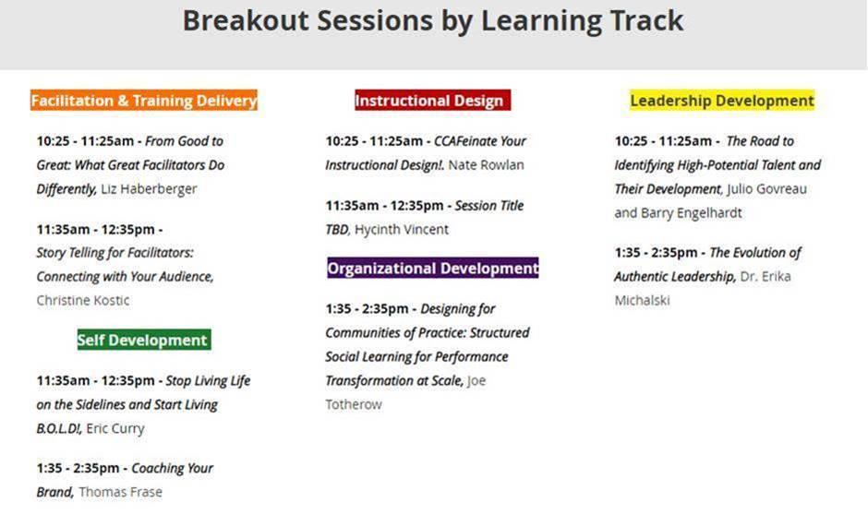

Please let me know your thoughts and if you would like additional information.

Thank you for your consideration!