Storytelling by Design with Christine Kostic
How Both Facilitators and Instructional Designers can Incorporate Stories into Training

Objectives:
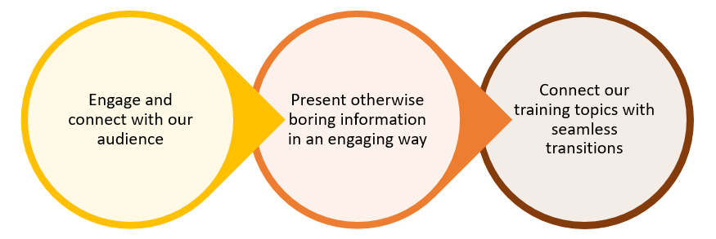

Types of Learners | Techniques to Use | Notes
Informative | Provide “nice to know” additional information, extra examples, reading materials, and other materials that encourage self-study
Practical | Give them just what they “need to know” for the content you’re teaching
Logical (Process) | Share data, facts, numbers, statistics, directions, quotes, charts, graphs, and lay out the steps to the process
Specific | Create structure with a detailed agenda, objectives, course outline
General | Give a global overview and allow the learner to structure content in a way that works for them
Social (Extravert) | Use a lot of discussions and group interactions and activities
Independent (Introvert) | Allow time to read, study, and process information independently before engaging in a group activity

Learning Preferences:
V________________ = __________%
A________________ = __________%
T________________ = __________%

Storytelling Methods that Appeal to Different Learning Styles:
- Ask questions / polls
- Tell / ask for a story
- Use a metaphor or analogy
- Show a video
- Demonstrate some kind of contrast
- Use pictures/visual aids
- Create a character

Notes:

It’s Your Turn!
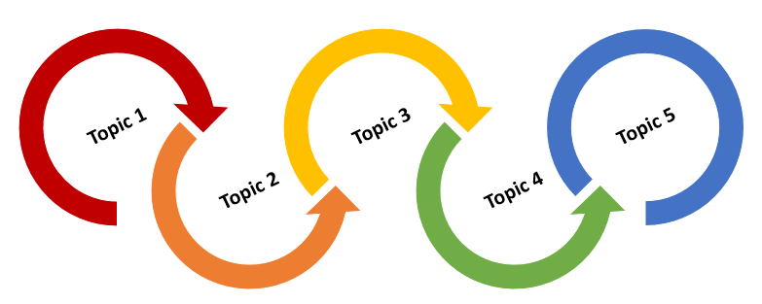
What is your main topic?

Objectives? Sub-topics?

How can you open your session?

How can you transition from one section to the next?

How can you close your session?

What will you do to ensure you are engaging all different learners?

Bonus Material:
Steps on How to Tell a Great Story:
- Frame the story. | 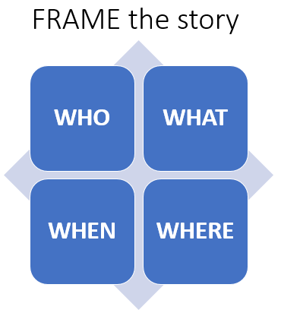
- Tell the story with a solid opening, middle, and ending. | 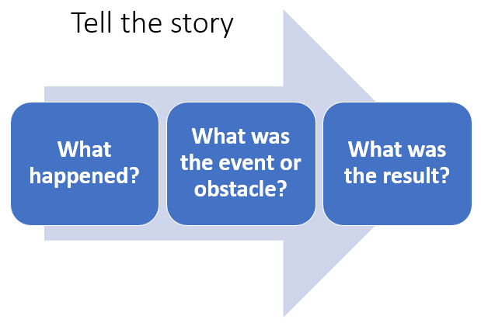
- Connect the story to the application, lesson, or purpose for telling it. | 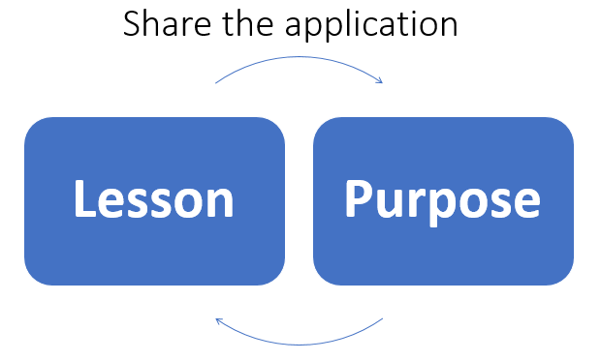

Additional Resources:
- The Storymatic Classic – Creative Writing Prompts and Story Games, Amazon
- TEDTalks Storytelling – 23 Storytelling Techniques from the Best TED Talks, by Akash Karia
- The Great Courses – Writing Great Fiction: Storytelling Tips and Techniques (www.thegreatcourses.com has a ton of great learning content taught by some of the best professors in the country, about countless topics!)
- Udemy – www.udemy.com is also a great resource for more training about training!

